CISC 250

Solution to Assignment 2

Transportation Layer Protocols

Network Layer Protocols

- A host sends a TCP segment with source port number 80 and destination port number 49892.
  - Is the host a server or a client? How can you tell? Explain the different types of port numbers.
  - If the host is a server, what kind of server is it?

- The host is a server. It is communicating at port 80 which is in the range of 0-1023 corresponding to well-known ports. Usually servers use such ports. Registered port numbers usually take the range of 1024 to 49152 and they are used for less central applications. Well known and registered port numbers should be used with IANA registration. These ports and their corresponding applications are listed at http://www.iana.org/assignments/port-numbers. Ephemeral port numbers, on the other hand, usually take the range of 49153 to 65535 (some older systems take the range of 1024 to 4999) and are assigned by the client kernel at run time. Clients usually use dynamic, ephemeral ports.

- Port 80 corresponds to a Web server.

- What is flow control? How does TCP handle flow control? For example, if a TCP segment from Host A to Host B contained bytes 15-39, the acknowledgement number from Host B acknowledging this segment is 40, and the Window Size field in this acknowledgement has a value of 50, then Host A may send through which byte?

If the sender transmits the information too fast, the receiver may be overwhelmed as it cannot accept the information at such rates. Hence it is necessary for the receiver to control the transmission rate. This is called flow control.

TCP accomplishes flow control using the Window size field in the TCP packet. The receiver tells how many more bytes the sender can send beyond the segment being acknowledged. If a TCP segment from Host A to Host B contained bytes 15-39, the acknowledgement number from Host B acknowledging this segment is 40, and the Window Size field in this acknowledgement has a value of 50, then Host A may send through byte 90. Host A must then stop unless the window has been extended in another acknowledgement.
Each Acknowledgement extends the window of bytes that may be sent, this is called a sliding window protocol.

- Write the following IP addresses in its binary form.

  - 128.175.21.80
  - 255.255.255.192
  - 127.0.0.1

a. Converting each decimal number of the IP into binary separately, we get the following:
 | 2^7=128 | 2^6=64 | 2^5=32 | 2^4=16 | 2^3=8 | 2^2=4 | 2^1=2 | 2^0=1
128 | 1 | 0 | 0 | 0 | 0 | 0 | 0 | 0
175 | 1 | 0 | 1 | 0 | 1 | 1 | 1 | 1
21 | 0 | 0 | 0 | 1 | 0 | 1 | 0 | 1
80 | 0 | 1 | 0 | 1 | 0 | 0 | 0 | 0
Hence the binary form of the IP address is
1000 0000 1010 1111 0001 0101 0101 0000

b. 1111 1111 1111 1111 1111 1111 1100 0000

c. 0111 1111 0000 0000 0000 0000 0000 0001

- What is the subnet address if the destination address is 19.30.84.5 and the mask is 255.255.192.0? Show your calculation.

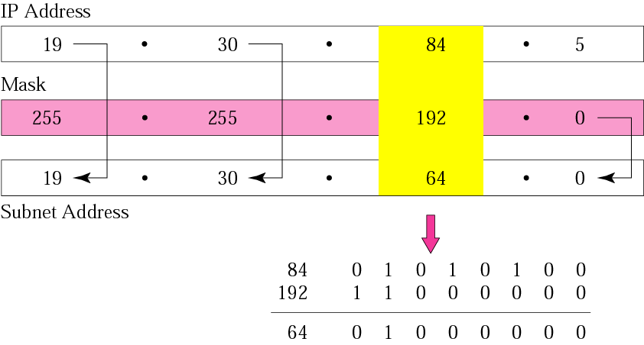

- You have a Class C 192.168.10.0 /28 network. How many usable subnets and hosts do you have? Explain your answer (show your calculation steps).

For a Class C network, you have 8 bits for the host part and 24 bits for the network part. With a /28 network prefix, you are taking 4 bits for your subnet part. Therefore, you will have (2⁴=16) subnets and (2⁴-2=14) hosts.

- How does a router make the routing decision based on the destination IP address and the routing table? Explain the routing algorithm with an example.

For each incoming IP packet, destination IP address is matched against every row in the routing table. If only one row matches, it will be selected as the best row match. If there are multiple matches, the row with the longest length of match is selected. If there are multiple rows with the same lengths of match, select the row with best metric (If the metric is cost, the smallest metric wins. If the metric is speed, the largest metric wins). Finally, the router sends the packet out from the interface in the best matching row to a host or router on the network or subnet out that port.

For example, with following routing table and the destination IP address 128.196.34.2, the address is masked with the subnet mask in each row in the routing table, and then the result is compared with the Network/Subnet value in that row. There are two matches: the subnets 128.196.0.0 and 128.196.34.0. The row of 128.196.34.0 is selected as the best match because it is the longest match. Therefore, the packet will be sent out through the interface 2 to the Next-hop-router (router C) listed in this best matching row.
